Part 1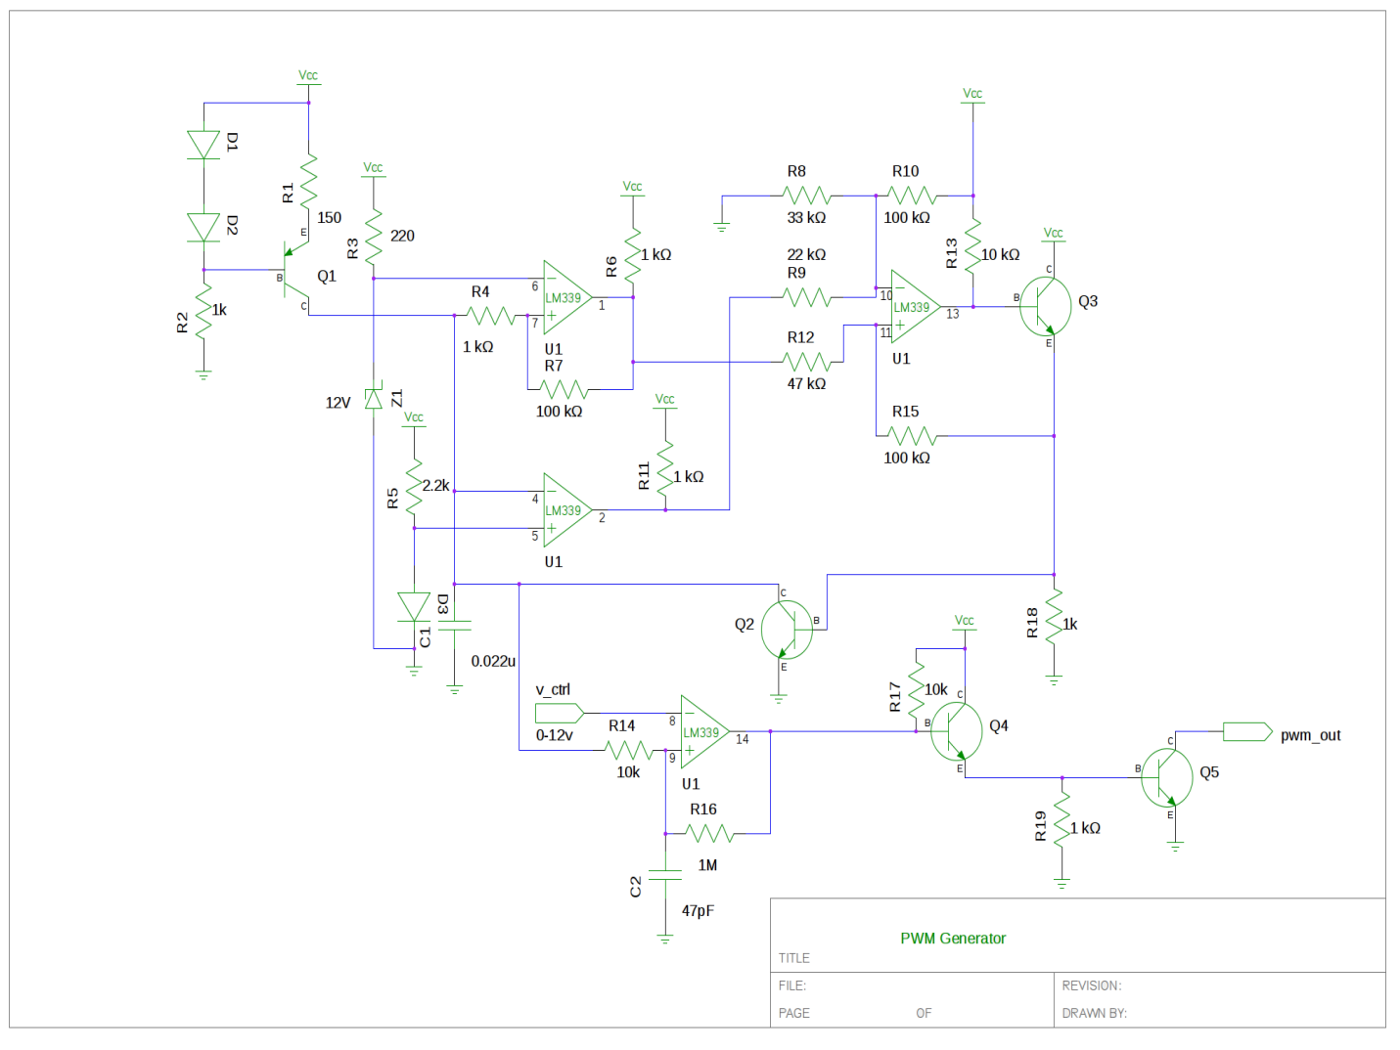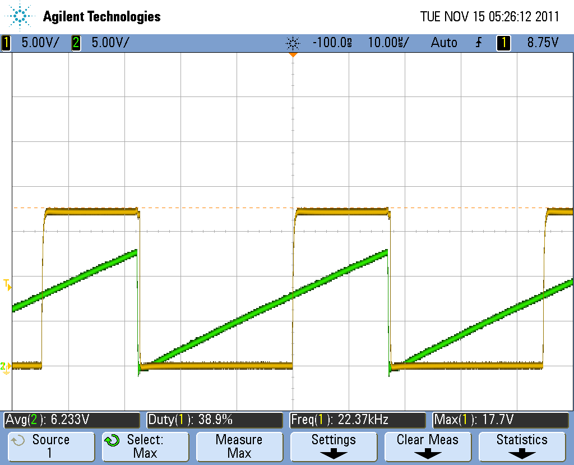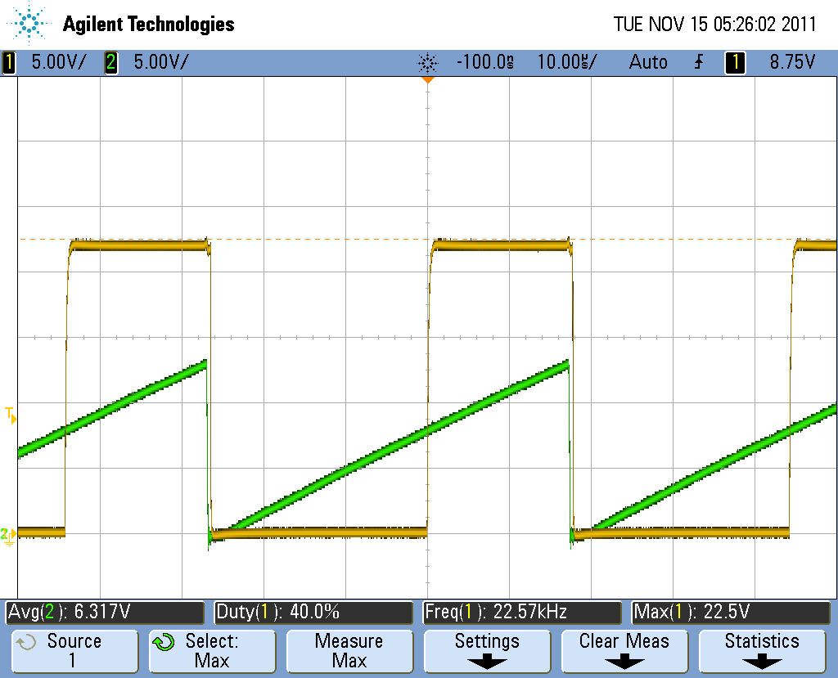

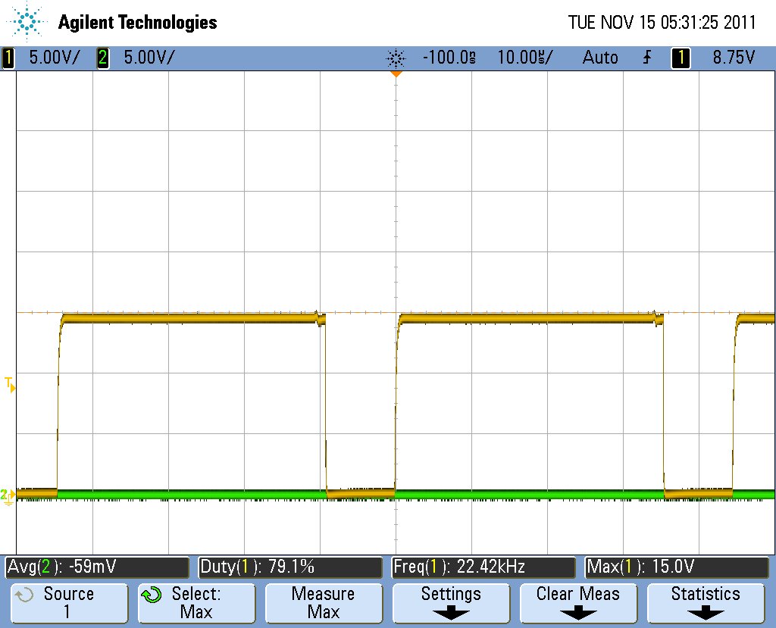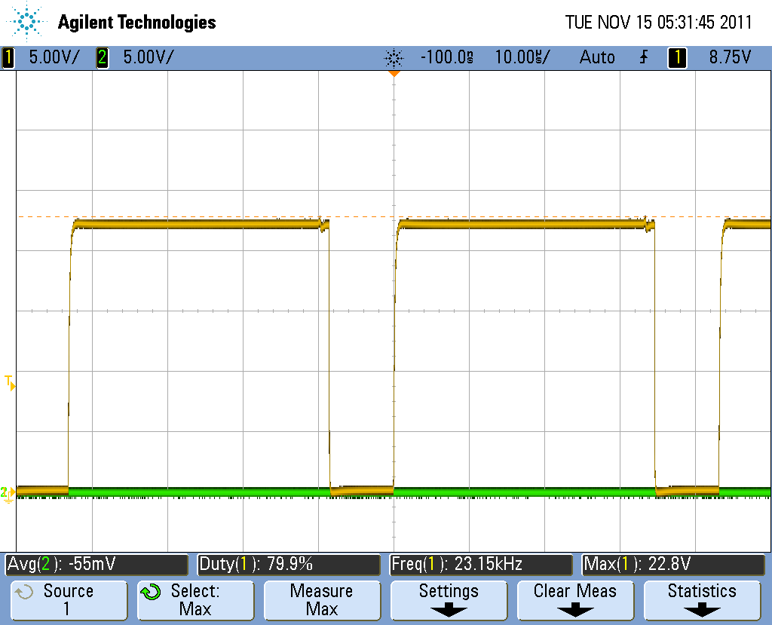

## Part 2

DCmin = 9%

DCmax = 72%

## Part 3B

REGline=0.75%

REGload=0.20%

Efficiency=26.84% (77.18% for only switcher; PWM generator draws 150mA)

Linear supply dissipation = (Vin – Vout)*I = (24v – 5v)*.3A = 5.7W

## Part 3C

Standard recovery diode efficiency = 23.92% (56.54% for just switcher)

Could not achieve any gains by slowing switching (gate resistor increased to 472ohm and 2672 ohm; negligible loss of efficiency)

## Part 4

Short Circuit Current = .321A (Before foldback kicks in) (see scope35)